**Contents of Sem V Project Report for Third Year M.Sc.(CA & IT)**

Project Title: Vortex Content Aggregator Platform

(By SEMESTER – V of III Year M.Sc.(CA & IT) 2022-23)

**Submitted By:**

Dev P. Gajjar-3107

Jeet P. Shah-3166

Mihir B. Solanki-3169

Group Id: 58

Name of the company: NEXTSTEP SOLUTIONS

Date of Submission: 04/12/2023

Submitted To

K. S. School of Business Management

M.Sc. - Computer Applications and Information Technology.

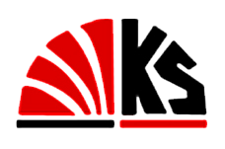

Certificate from Company

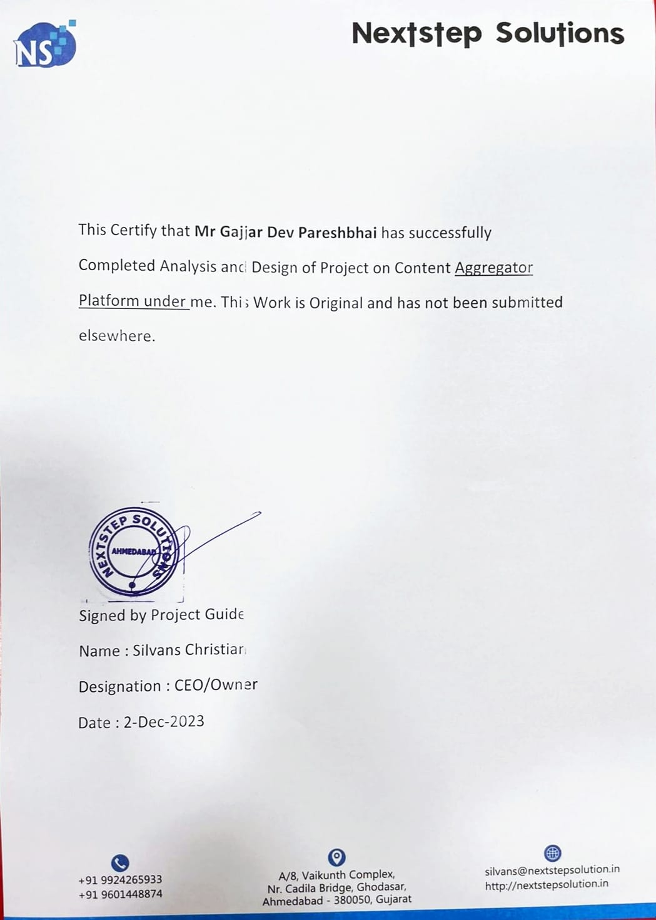

Certificate from Company

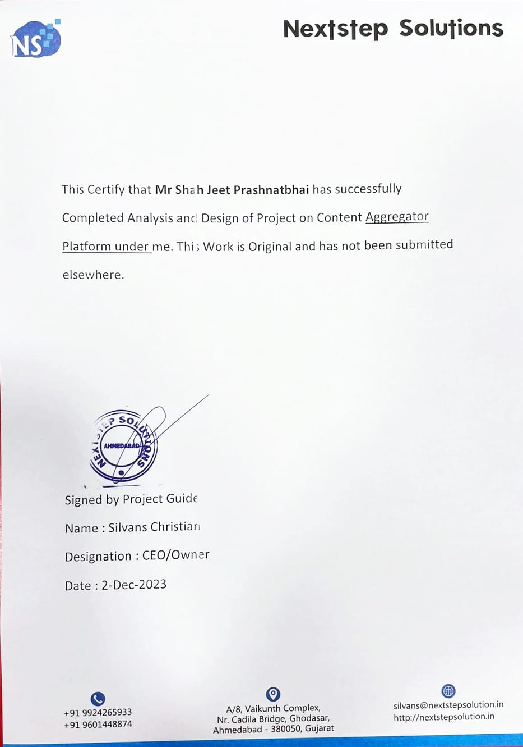

Certificate from Company

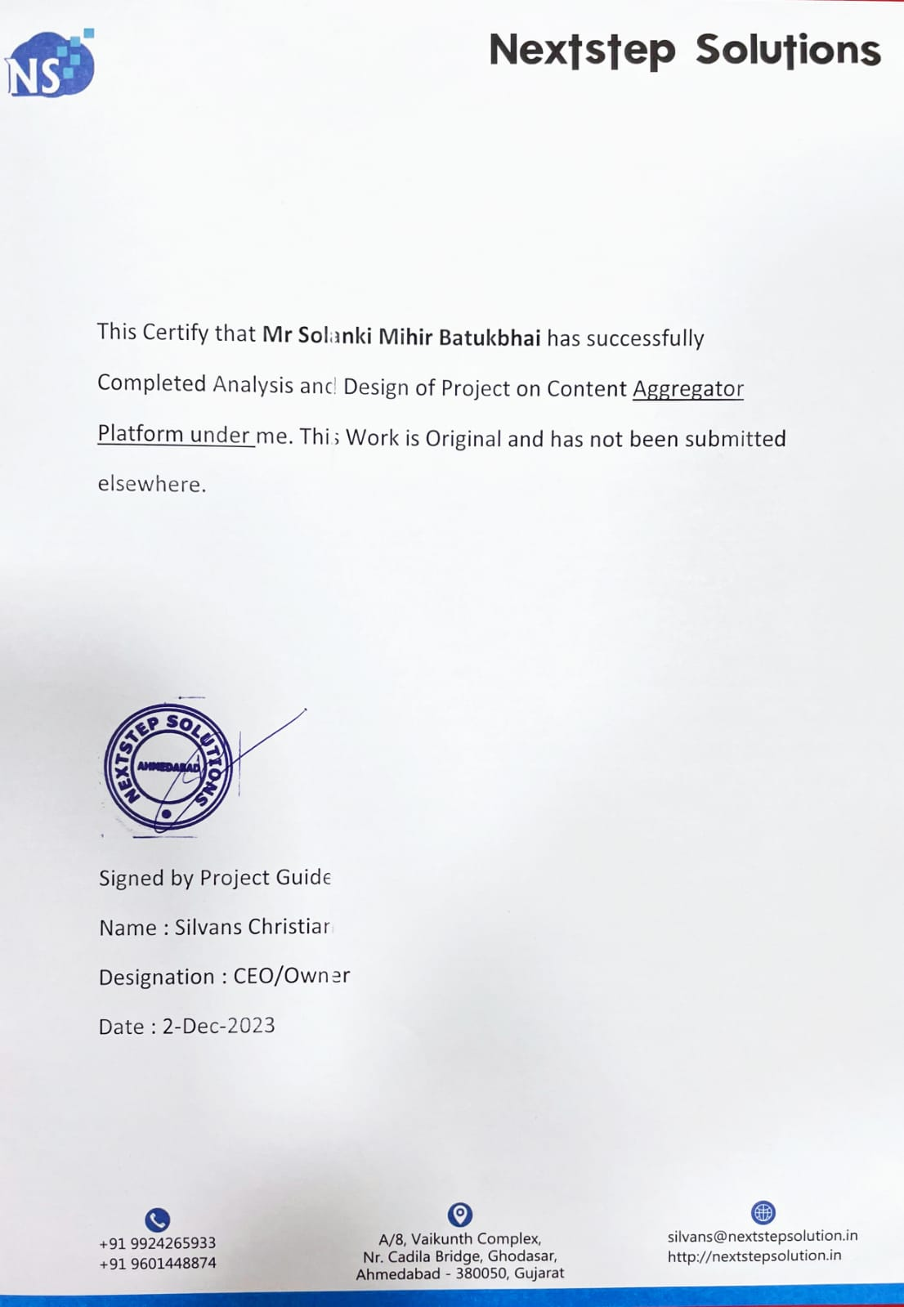

Acknowledgement

We are thankful to **K.S. School Of Business Management And Information Technology** for giving us an opportunity to learn several new concepts this project and providing administrating help whenever needed. The feeling of acknowledge and expressing it in words are two things apart. We honestly admit when we truly wish to express our warm gratitude and indebtedness towards somebody, we are always at loss of word.

We acknowledgement the management staff of “NextStep Solutions” for giving us permission to develop “Vortex Content Aggregator Platform” for business and helping us in understanding the current system which is a valuable input for developing the system.

With Regards

Dev P. Gajjar – 3107

Jeet P. Shah – 3166

Mihir B. Solanki - 3169

Table of Contents

Chapter - 1 9

1 INTRODUCTION 9

1.1 ORGANIZATION PROFILE 9

1.2 SYSTEM DETAILS 10

1.2.1 EXISTING SYSTEM 10

1.2.2 PROPOSED SYSTEM 10

1.3 SCOPE OF SYSTEM 11

1.4 OBJECTIVES 11

Chapter 2 12

2 PROPOSED SYSTEM REQUIREMENT GATHETING 12

2.1 STAKEHOLDER OF SYSTEM 12

2.2 REQUIREMENT GATHERING TECHNIQUE USED 14

2.3 CONSOLIDATED LIST OF REQUIREMENTS 16

2.4 PROJECT DEFINITION 17

Chapter 3 18

3 SYSTEM MANAGEMENT AND PLANNING 18

3.1 FEASIBILITY STUDY 18

3.1.1 TECHNICAL STUDY 18

3.1.2 ECONOMICAL STUDY 19

3.1.3 Operational study 20

3.2 HARDWARE-SOFTWARE REQUIREMENT 21

3.2.1 Client-side Requirements 21

3.2.2 Server-side Requirements 21

3.3 System planning 22

3.3.1 Work breakdown chart 22

3.3.2 Gantt chart 23

3.4 PROCESS MODEL 25

Chapter 4 27

4 SYSTEM ANALYSIS AND PLANNING 27

4.1 UML(UNIFIED MODELING LANGUAGE) 27

4.1.1 Use-Case Diagram 28

4.1.2 Activity Diagram 31

4.1.3 Sequence Diagram 35

4.1.4 Class Diagram 39

4.2 System Flow Diagram 41

4.2.1 Architecture Context Diagram 42

4.3 DATA DICTIONARY 43

4.4 USER INTERFACE 47

4.5 SYSTEM NAVIGATION 54

**BIBILIOGRAPHY**

1. [www.geeksforgeeks.org](http://www.geeksforgeeks.org)

2. <https://www.lucidchart.com/pages/>

3. [www.figma.com](http://www.figma.com)

4. [www.canva.com](http://www.canva.com)

5. <https://app.diagrams.net/>

7.[www.youtube.com](http://www.youtube.com)

# Chapter - 1

# 1 INTRODUCTION

In the digital age, where visual content plays a pivotal role in various fields, from web development to marketing, finding high-quality and relevant images quickly and efficiently can be a daunting task. This is where our "Content Aggregator Platform," Vortex, steps in as a game-changer. This innovative platform leverages the power of APIs to access a vast array of images from different sources across the internet and presents them to users in an organized and centralized manner. Vortex aims to simplify the process of discovering and accessing visual content, making it an indispensable tool for students, individuals, designers, businesses, marketers, content creators, and anyone seeking to enhance their projects, presentations, websites, and social media posts.

Our platform, Vortex, is designed to address the challenges users face in searching for accurate and fitting visual content for their specific needs. By offering a centralized hub for image discovery, it eliminates the need to visit multiple websites individually, saving users valuable time and effort. Additionally, Vortex provides a wealth of benefits, including creative freedom, centralized information, time savings, branding opportunities, inspiration, and exploration. Users can contribute to Vortex, fostering a dynamic and diverse image pool.

## 1.1 ORGANIZATION PROFILE

NextStep Solutions is an IT web service provider company that specializes in creating unique online presences for businesses, helping them outperform their competitors. They promise to deliver high-quality, custom-built software and web services that set their clients apart from the competition.

|  |  |
| --- | --- |
|  | COMPANY NAME:  NEXTSTEP SOLUTIONS |

ABOUT:

|  |  |
| --- | --- |
| Company CEO name: | Mr Silvans Christian |
| Since: | 2018 |
| Website: | http://nextstepsolution.in |
| Email: | Nextstepsolutions19@gmail.com |
| Phone no: | +91 7990324474 |
| Address: | A8, Vaikunth Complex, Ghodasar, Ahmedabad. |

## 1.2 SYSTEM DETAILS

### 1.2.1 EXISTING SYSTEM

* In the existing system, users rely on search engines like Google, Bing, or Shutterstock, Getty Images to find images.
* Users have to manually visit multiple websites or use various search engines to look for images based on their keywords.
* There is no centralized platform that aggregates images from multiple sources and provides a unified search experience.
* Users may face copyright issues when using images from various sources without proper attribution or licensing.

### 1.2.2 PROPOSED SYSTEM

* The proposed system is a Vortex that uses APIs to access data from various websites and presents images based on user-searched keywords.
* Users can enter a keyword, and the platform will retrieve images from multiple sources, providing a centralized and organized display of results.
* The platform aims to save users time and effort by eliminating the need to visit multiple websites individually.
* It offers a user-friendly interface, advanced search options, and filters to enhance the user experience. Enabling users to share images directly from the platform to social media or messaging apps. Allowing users to create collections or albums to organize their favourite images.
* Giving users the option to create profiles where they can manage their saved images and preferences.
* The platform will cater to students, individuals, designers, businesses, marketers, and content creators, offering high-quality images for various purposes.
* Monetization involves generating revenue through various strategies such as offering subscription plans, using affiliate marketing, premium version and exclusive images, featuring sponsored content.
* It will also encourage user contributions, allowing individuals to submit their images to enrich the platform's content.

## 1.3 SCOPE OF SYSTEM

* Keyword-Based Image Search
* API Integration for Data Retrieval
* Centralized and Organized Image Display
* Serving a Diverse User Base
* Image Usage for Enhancing Projects
* Providing Creative Freedom
* Time-Saving Image Search
* Supporting Branding Strategies
* Facilitating Inspiration and Exploration
* User Contribution to Expand Content
* Focusing on Efficiency in Content Access
* User-Friendly Interface Design
* Implementing Robust Security Measures
* Planning for Scalability and Growth
* Exploring Monetization Options for Sustainability

## 1.4 OBJECTIVES

* **Simplify Image Discovery:** Make it easy for users to discover high-quality images.
* **Diverse User Base:** Cater to a wide range of users, including students, designers, businesses, and marketers.
* **Efficient Keyword Searches:** Offer efficient image searches through keywords for user convenience.
* **Centralized Visual Content:** Aggregate visual content from various online sources and centralize it in one place.
* **Time Savings:** Save users time by eliminating the need to visit multiple websites for images.
* **Image Variety:** Provide a wide variety of images to enhance creative freedom in projects and presentations.
* **Branding Alignment:** Enable businesses and marketers to align their branding efforts with curated images.
* **Diverse Image Library:** Maintain a diverse image library to inspire and support creative exploration.
* **User Contributions**: Encourage user contributions to enrich the platform's content and foster a vibrant community.

# Chapter 2

# 2 PROPOSED SYSTEM REQUIREMENT GATHETING

Proposed system requirement gathering is a crucial phase in the web development process for our Content Aggregator Platform, Vortex. It involves collecting and documenting the specifications, features, and constraints for a new or enhanced software system that is being proposed. This phase serves as the foundation for the entire software development project and ensures that the development team and stakeholders, including those involved in Vortex, have a clear understanding of what the system should accomplish.

## 2.1 STAKEHOLDER OF SYSTEM

**Administrators and Moderators:**

* Manage content aggregation and quality control.
* Handle keyword management and organization.
* Ensure user management and access control.
* Maintain a safe and positive user environment.
* Address user-reported issues and concerns.
* Play a crucial role in platform maintenance.

**Users:**

* Diverse user base including students, designers, businesses, marketers, and content creators.
* Seek images for projects, presentations, websites, and social media.
* Drive platform engagement and content consumption.

**Content Sources:**

* External providers, websites, and databases.
* Supply images through API integration.
* Maintaining positive relationships is vital for content flow.

**API Providers:**

* External organizations offering APIs.
* API integration expands available image sources.

**Payment Processors:**

* Handle secure transactions.
* Facilitate subscription plans and premium offerings.
* Ensure financial transactions are smooth and secure.

**User Support Team:**

* Assist users with queries and technical issues.
* Provide prompt and effective user support.
* Enhance user satisfaction and retention.

**Developers:**

* Build and maintain the platform.
* Integrate external APIs.
* Manage databases, security, and performance optimization.
* Develop new features and improvements.

**Designers and UX/UI Specialists:**

* Create user-friendly, visually appealing interface.
* Optimize design for various devices.
* Enhance overall user experience.

**Content Creators and Contributors:**

* Users who contribute images.
* Expand the platform's content library.
* Maintain content relevance.

## 

## REQUIREMENT GATHERING TECHNIQUE USED

**Interview:**

**Title: Interview as a Requirement Gathering Technique for a Vortex.**

This article delves into the significance of interview as a requirement gathering method for a content aggregator platform, exploring how this technique can help develop a platform that truly resonates with its users and creators.

**Interviewer**: Thank you for joining us today. To get started, could you briefly describe the primary objectives of your Content Aggregator Platform?

**Response**: Our platform's primary objective is to provide users with a convenient and efficient way to discover and access high-quality images based on their specific interests or needs. We aim to centralize image search from various sources, ultimately saving users time and effort when looking for visuals for their projects, presentations, websites, and social media posts.

**Interviewer**: That sounds promising. Can you tell us more about the key features that users will find on your platform to achieve these objectives?

**Response:** Certainly. Our platform offers several key features. Users can perform keyword-based searches to find images, and we provide advanced filtering options to refine search results based on criteria like image type. Users can save or download selected images, share them on social media, and organize their favourite visuals into collections or albums. We also offer user profiles where users can manage their saved images and preferences, creating a personalized experience.

**Interviewer:** That's great to hear. What about user engagement and interaction on your platform? Are there any specific strategies you plan to implement to keep users engaged?

**Response:** Yes, user engagement is a priority. We plan to integrate social media, allowing users to share their curated collections and discoveries with their acquaintance and more. By fostering a sense of community and recognition, we aim to enhance user engagement.

**Interviewer:** Monetization is a crucial aspect of many platforms. Can you explain your monetization strategies briefly?

**Response:** Of course. We have two primary monetization strategies. First, we offer a premium version with advanced features and exclusive content to users who subscribe. Second, we provide opportunities for brands and businesses to sponsor specific image categories or collections, increasing their visibility to our users. These strategies help generate revenue while offering added value to both users and sponsors.

**Interviewer:** Thank you for sharing these insights into your Content Aggregator Platform. It's been a pleasure discussing your platform's goals and features with you.

**Response:** You're welcome. Thank you for the opportunity to discuss our platform, and we're excited to bring these ideas to life to benefit our users.

**Questionnaires:**

* Are there particular content sources or types of content you want to prioritize for integration into the platform?
* We plan to prioritize integration with reputable and diverse content sources through APIs. This will allow us to fetch images from various external providers, ensuring a wide selection of content to meet users' preferences and requirements. We aim to maintain positive relationships with content sources to ensure a continuous flow of high-quality images.
* What monetization strategies do you believe will be most effective and sustainable for the platform?
* Our monetization strategy involves offering premium features, subscription plans, affiliate marketing, and exclusive content to users who seek additional benefits.
* How can the platform provide value to users while generating revenue?
* We also plan to display non-intrusive ads and explore sponsored content opportunities to generate revenue while providing value to our users.
* What aspects of the user interface and user experience are most important to you and the users?
* Ensuring a positive user experience is a top priority. We aim to create a visually appealing and user-friendly interface that caters to different devices and screen sizes.
* What information should be collected during the user registration process?
* During user registration, we will collect essential information, such as full name, email, username, and preferences while ensuring transparency and respecting user privacy during the registration process.
* What security measures and practices should the platform implement to protect user data and privacy?
* We take data security seriously and will implement strong security practices, including encryption, authentication, access controls. These measures are crucial for protecting user data and maintaining the integrity and privacy of our platform's operations.

**Brainstorming session:**

User Registration and Profiles:

* Users can register accounts and create profiles.
* Profiles allow for personalization and customization.

Search and Discovery:

* Users can input keywords or phrases to search for images.
* The platform employs algorithms to retrieve and display relevant images.

Monetization Strategies:

* Premium version: Offer premium users advance access to exclusive content.
* Sponsored Content: Allow brands and businesses to sponsor specific image categories or collections for increased visibility.

## CONSOLIDATED LIST OF REQUIREMENTS

User Requirements:

* User registration and profile management.
* Content discovery, search, and advanced filtering.
* Content interaction, saving, and sharing.
* Content organization through collections.
* User engagement.

Administrative Requirements:

* Content management, including addition, editing, and removal.
* Keyword management for content discoverability.
* Content moderation and reporting tools.
* Search optimization.
* Retrieval
* API integration for external sources.
* Robust security measures.
* Content Display
* User Interaction
* Content Providers (API integration)

Monetization Requirements:

* Premium subscription plans.
* Non-intrusive ad display.
* Payment processing for subscriptions and ads.
* Support for affiliate marketing programs

## PROJECT DEFINITION

A website that uses APIs to access data from other websites and displays images based on the searched keyword is commonly known as an "aggregator website" or "content aggregator platform." Such websites use APIs to retrieve content from various sources and present it to users in a centralized and organized manner, making it easier to find relevant images based on the user’s keyword search. This saves users the time and effort of searching multiple websites or databases for the images they need.

As students, we have faced issues finding proper and accurate content for web development and websites. Therefore, we would like to introduce our platform, Vortex, that provides images based on searched keywords, offering users a convenient and efficient way to discover and access relevant visual content from various sources across the internet. Vortex helps users find images related to their interests or needs without having to visit multiple websites individually. It centralizes image search, making it easier for users to locate and access the images they’re looking for, ultimately saving them time and effort.

Vortex is aimed at students, individuals, designers, businesses, marketers, and content creators to enhance their projects, presentations, websites, and social media posts. The objective of Vortex is to simplify the process of finding and accessing high-quality images, providing creative freedom, centralized information, time savings, branding opportunities, inspiration, and exploration, with the active contribution of users.

# Chapter 3

# 3 SYSTEM MANAGEMENT AND PLANNING

In Chapter 3, System management and planning, underpin the technical, economic, and operational feasibility of our Content Aggregator Platform, Vortex. We've meticulously addressed the hardware and software requirements, including server infrastructure, caching mechanisms, and content delivery networks, to support scalability and optimize performance for Vortex. Security measures, such as encryption and authentication, are in place to protect user data and instill trust. Monitoring tools and proactive user support systems will maintain operational efficiency for Vortex, while content management and moderation procedures guarantee content quality. We are committed to regulatory compliance, cost optimization, and long-term viability for Vortex. In addition to technical and economic feasibility, the development process is well-structured with a comprehensive work breakdown diagram, Gantt chart, and process model, enabling efficient project management and successful implementation of Vortex.

## 3.1 FEASIBILITY STUDY

A feasibility study for a Content Aggregator Platform is a comprehensive assessment aimed at determining the practicality and viability of bringing this innovative digital solution to life. This study delves into the technical, economic, and operational aspects of the project, exploring the hardware and software requirements, scalability, and performance optimization. It also delves into the revenue-generating potential, cost management, and user satisfaction strategies.

### 3.1.1 TECHNICAL STUDY

The technical feasibility assessment for a Vortex involves evaluating whether the digital infrastructure, software, and resources required to build and maintain the platform are both achievable and effective. It aims to determine if the technical aspects are feasible, ensuring the platform's functionality, performance, and scalability in a digital landscape.

**Proficiency:**

The proficiency of the developer team is a critical factor in assessing the technical feasibility of a Content Aggregator Platform. The team's expertise in web development, API integration, database management, security, and other relevant technical domains is pivotal. Their ability to design and implement a scalable, secure, and high-performance platform is fundamental to ensuring the project's technical viability. The team's experience and competence directly impact the project's success and its ability to meet the defined technical requirement.

**Hardware Infrastructure:**

This encompasses the physical components that make up the platform's computational and storage capacity. It includes servers, data centers, networking equipment. Scalability, reliability, and processing power are vital considerations within the hardware infrastructure to support the platform's growth and performance.

**Software Ecosystem**:

The software ecosystem includes the operating systems, programming languages, web development frameworks, databases, and third-party tools used to build and run the platform. This ecosystem determines how efficiently the platform processes data, serves content, and maintains security. API integration, content management systems.

**Conclusion:** In summary, the technical feasibility assessment for Vortex demonstrates a strong foundation for its successful implementation. The hardware infrastructure and software ecosystem have been meticulously

designed to ensure scalability, security, and high performance. Our proficient developer team further strengthens our technical capabilities. This evaluation affirms that our platform is poised to function effectively and adapt to the dynamic digital landscape, instilling confidence in its technical feasibility.

### 3.1.2 ECONOMICAL STUDY

In the realm of the economic feasibility study for our Content Aggregator Platform, we meticulously examine the financial landscape. This involves a close analysis of costs, revenue potential, and sustainability. We consider the practicality of our revenue streams and break-even points. This economic study serves as a compass, guiding us towards a fiscally sustainable and thriving digital venture.

**Initial Development Costs:**

**1. Development Costs**: our Content Aggregator Platform's development costs encompass a range of initial expenses that are foundational to its successful launch. These costs include software and hardware acquisition and maintenance, licensing fees for critical software tools and frameworks, and the setup and configuration of servers and network infrastructure. This phase not only involves procurement but also significant efforts in coding and system design, all of which are essential for establishing a robust foundation that ensures the functionality and performance of our platform

**2. Server Infrastructure:** Anticipated expenses involve server hosting, cloud services, and network infrastructure. This includes monthly server hosting fees, data storage

costs, and internet bandwidth expenses.

**3. API Integration**: Costs related to connecting with external data sources and services.

**4. Marketing and Promotion:** Budget for marketing the platform to attract the initial user base.

**Revenue Streams:**

**1. Advertising**: Generate income through advertisements placed on your platform. This can include display ads, sponsored content, and affiliate marketing partnerships.

**2. Premium Subscriptions:** Offer premium subscription plans that grant users access to exclusive features, higher-quality content, or an ad-free experience. Subscribers pay a recurring fee for these benefits.

**3. Freemium Model:** Provide a free version of the platform with basic features and content, while offering premium or advanced features at a price. Users can choose to upgrade to access these additional features.

**4. Pay-Per-Use**: Implement a pay-per-use model, where users pay a fee for each download or access to specific premium content.

**5. Sponsored Content:** Partner with brands and businesses to feature their content or products on your platform for a fee. Sponsored content can be seamlessly integrated with other content.

**6. Affiliate Marketing:** Earn commissions by promoting and selling products or services from third-party websites through affiliate links. You get a percentage of the sales generated through these referrals.

**Break-even Analysis:**

This analysis predicts that Content aggregator platform is expected to become profitable within the first 6-8 months of operation. Initial costs will be offset by rising revenues generated through subscriptions, advertising,affiliate marketing etc.

**Financial Viability:**

The economic study of our Content Aggregator Platform places a critical emphasis on financial viability and sustainability. The sustainability assessment extends its gaze into the long-term financial model, aiming to secure the platform's economic feasibility throughout its lifecycle. This assessment considers crucial factors, including adaptability to market changes, regular updates and upgrades, efficient scaling, and diversification of revenue streams. It is a proactive approach to ensure that our platform not only thrives initially but remains economically robust and adaptable over time.

**Conclusion:**

The economic study underscores the vital importance of financial viability and sustainability for our Content Aggregator Platform. By assessing long-term financial models and considering adaptability to market changes, regular updates, efficient scaling, and diversified revenue streams, we ensure the platform's resilience and longevity. This proactive approach is key to our platform's success in a dynamic digital landscape.

### 3.1.3 Operational study

An operational study for Vortex is crucial for ensuring its efficient and effective day-to-day functioning. Here are the key aspects to cover in your operational study:

**Integration strategies:**

Content integration strategies for Vortex are designed to efficiently collect, categorize, and present diverse content from multiple sources. These strategies encompass automation to ensure real-time updates, effective categorization, rigorous quality control to maintain content standards, consistency in presentation for a uniform user experience, and scalability to accommodate a growing user base and expanding content sources. These efforts collectively enhance the platform's value by providing users with a seamless and high-quality content discovery experience.

**Content Integration:**

**Source Diversity**: Assess the variety of content sources, such as websites, APIs, and databases, and how they are integrated into the platform.

**Automation:** Detail the automation processes involved in content aggregation to ensure real-time updates and minimal manual intervention.

**Quality Control:** Address measures in place to filter and maintain high-quality content while adhering to content guidelines and standards.

**Consistency:** Maintaining consistency in content presentation, ensuring a uniform user experience.

**Scalability:** Scale content integration to accommodate an expanding user base and diversify content sources.

**Conclusion:**

The operational study of our Vortex’s Platform serves as the cornerstone of our project's success. It highlights the significance of a well-structured operational framework, which facilitates seamless content integration, enhances user interaction, maintains content quality, and allows for adaptable scalability. Our unwavering commitment to data security, user support, and regulatory compliance ensures a safe and enjoyable user experience. By comprehensively addressing monetization strategies and efficient content management, we lay the foundation for a sustainable and flourishing platform. This operational study not only meets but exceeds user expectations and positions our platform to thrive in the dynamic digital landscape.

## 3.2 HARDWARE-SOFTWARE REQUIREMENT

### 3.2.1 Client-side Requirements

Hardware Requirements

|  |  |
| --- | --- |
| Processor | All Processor |
| RAM | 1GB or Higher |

Software Requirements

|  |  |
| --- | --- |
| OS | Any Operating System |
| Browser | Any Browser which support Javascript |

### 3.2.2 Server-side Requirements

Hardware Requirements

|  |  |
| --- | --- |
| Processor | Dual-Core or Higher |
| RAM | 1GB or Higher |
| Storage | 120GB or Higher |

Software Requirements

|  |  |
| --- | --- |
| OS | Windows, macOS, Linux. |
| Frontend programming languages | HTML, CSS, React JS |
| Backend programming Language | Python/ Django. |
| Database | PostgreSQL |

## 3.3 System planning

System planning for a content aggregator involves defining the platform's objectives, target audience, and content sources, as well as outlining the technical infrastructure and development approach to ensure effective content gathering and delivery.

### 3.3.1 Work breakdown chart

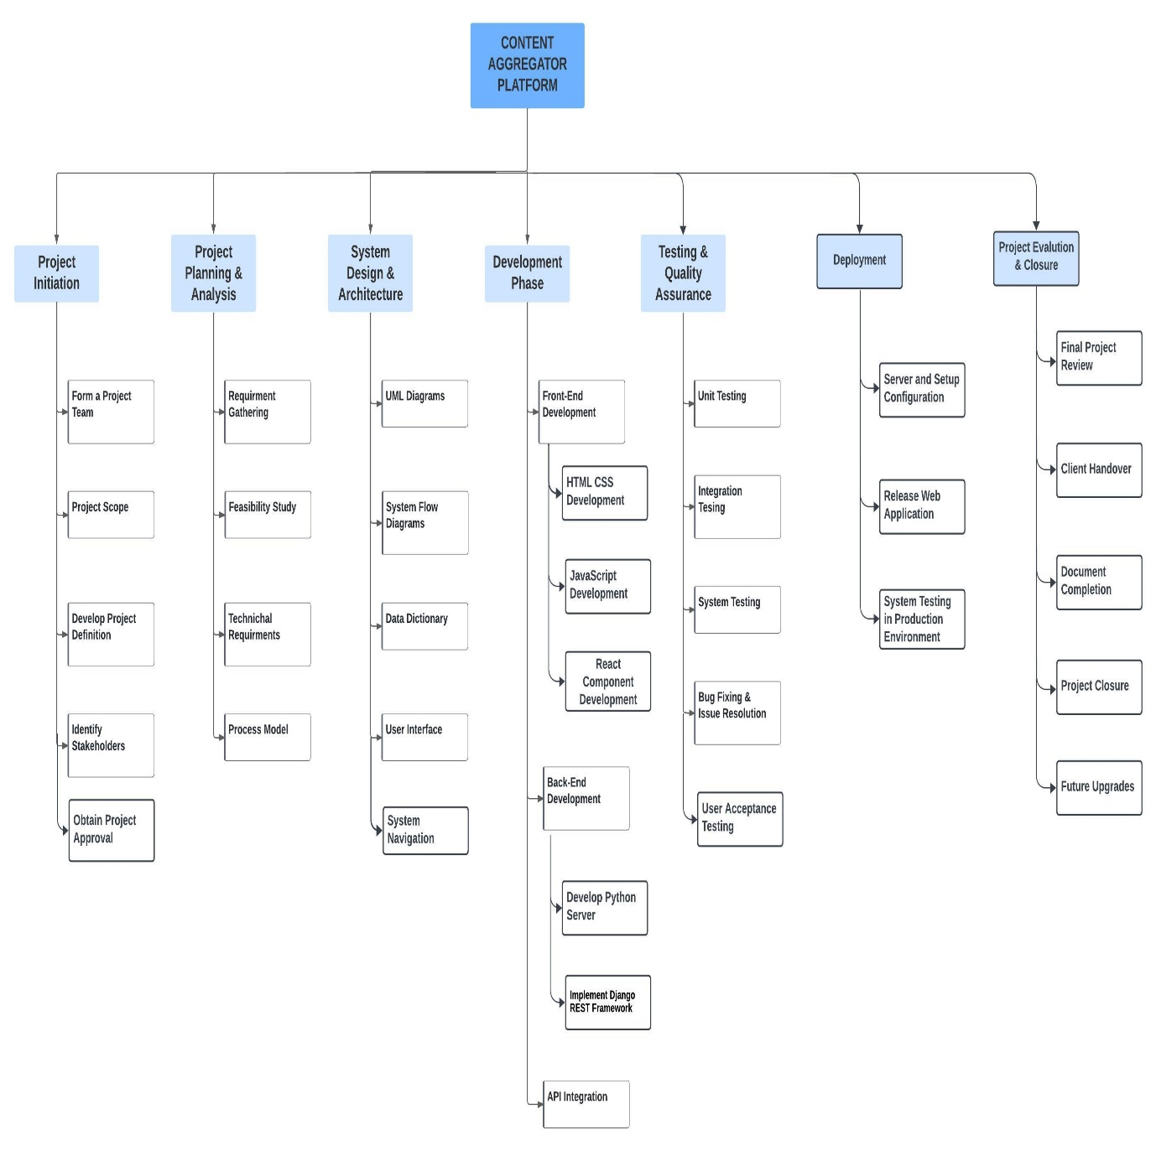

### 3.3.2 Gantt chart

The Gantt Chart for Vortex is a visual roadmap outlining the project schedule. It succinctly presents tasks, milestones, and timelines, aiding in effective project management. This tool is crucial for tracking progress, managing resources, and ensuring that every stage of Vortex's development aligns seamlessly with its objectives.

|  |  |  |  |  |  |  |  |  |
| --- | --- | --- | --- | --- | --- | --- | --- | --- |
| Task | September | October | November | December | January | February | March | April |
| 1.1 Organisation Profile |  |  |  |  |  |  |  |  |
| 1.2 System Details  1.2.1 Existing System  1.2.2 Proposed System |  |  |  |  |  |  |  |  |
| 1.3 Scope of System |  |  |  |  |  |  |  |  |
| 1.4 Objectives |  |  |  |  |  |  |  |  |

|  |  |  |  |  |  |  |  |  |
| --- | --- | --- | --- | --- | --- | --- | --- | --- |
| 2.1 Stakeholders of System |  |  |  |  |  |  |  |  |
| 2.2 Requirement Gathering Techniques |  |  |  |  |  |  |  |  |
| 2.3 Consolidated List of Requirements |  |  |  |  |  |  |  |  |
| 2.4 Project Definition |  |  |  |  |  |  |  |  |

|  |  |  |  |  |  |  |  |  |
| --- | --- | --- | --- | --- | --- | --- | --- | --- |
| 3.1 Feasibility Study  3.1.1 Technical Study  3.1.2 Economical Study  3.1.3 Operational Study |  |  |  |  |  |  |  |  |
| 3.2 Hardware Software Requirements |  |  |  |  |  |  |  |  |
| 3.3 System Planning  3.3.1 Work Breakdown Structure  3.3.2 Gantt Chart |  |  |  |  |  |  |  |  |
| 3.4 Process Model |  |  |  |  |  |  |  |  |

|  |  |  |  |  |  |  |  |  |
| --- | --- | --- | --- | --- | --- | --- | --- | --- |
| 4.1 Unified Modelling Language |  |  |  |  |  |  |  |  |
| 4.2 System Flow Diagram |  |  |  |  |  |  |  |  |
| 4.3 Data Dictionary |  |  |  |  |  |  |  |  |
| 4.4 User Interface |  |  |  |  |  |  |  |  |
| 4.5 System Navigation |  |  |  |  |  |  |  |  |

## 3.4 PROCESS MODEL

**Incremental Iterative model:**

Vortex utilizes a hybrid strategy that merges the iterative and incremental models, promoting a dynamic and flexible development process. This model provides a methodical and adaptable approach to software development, enabling the content aggregator platform to grow and adjust efficiently.

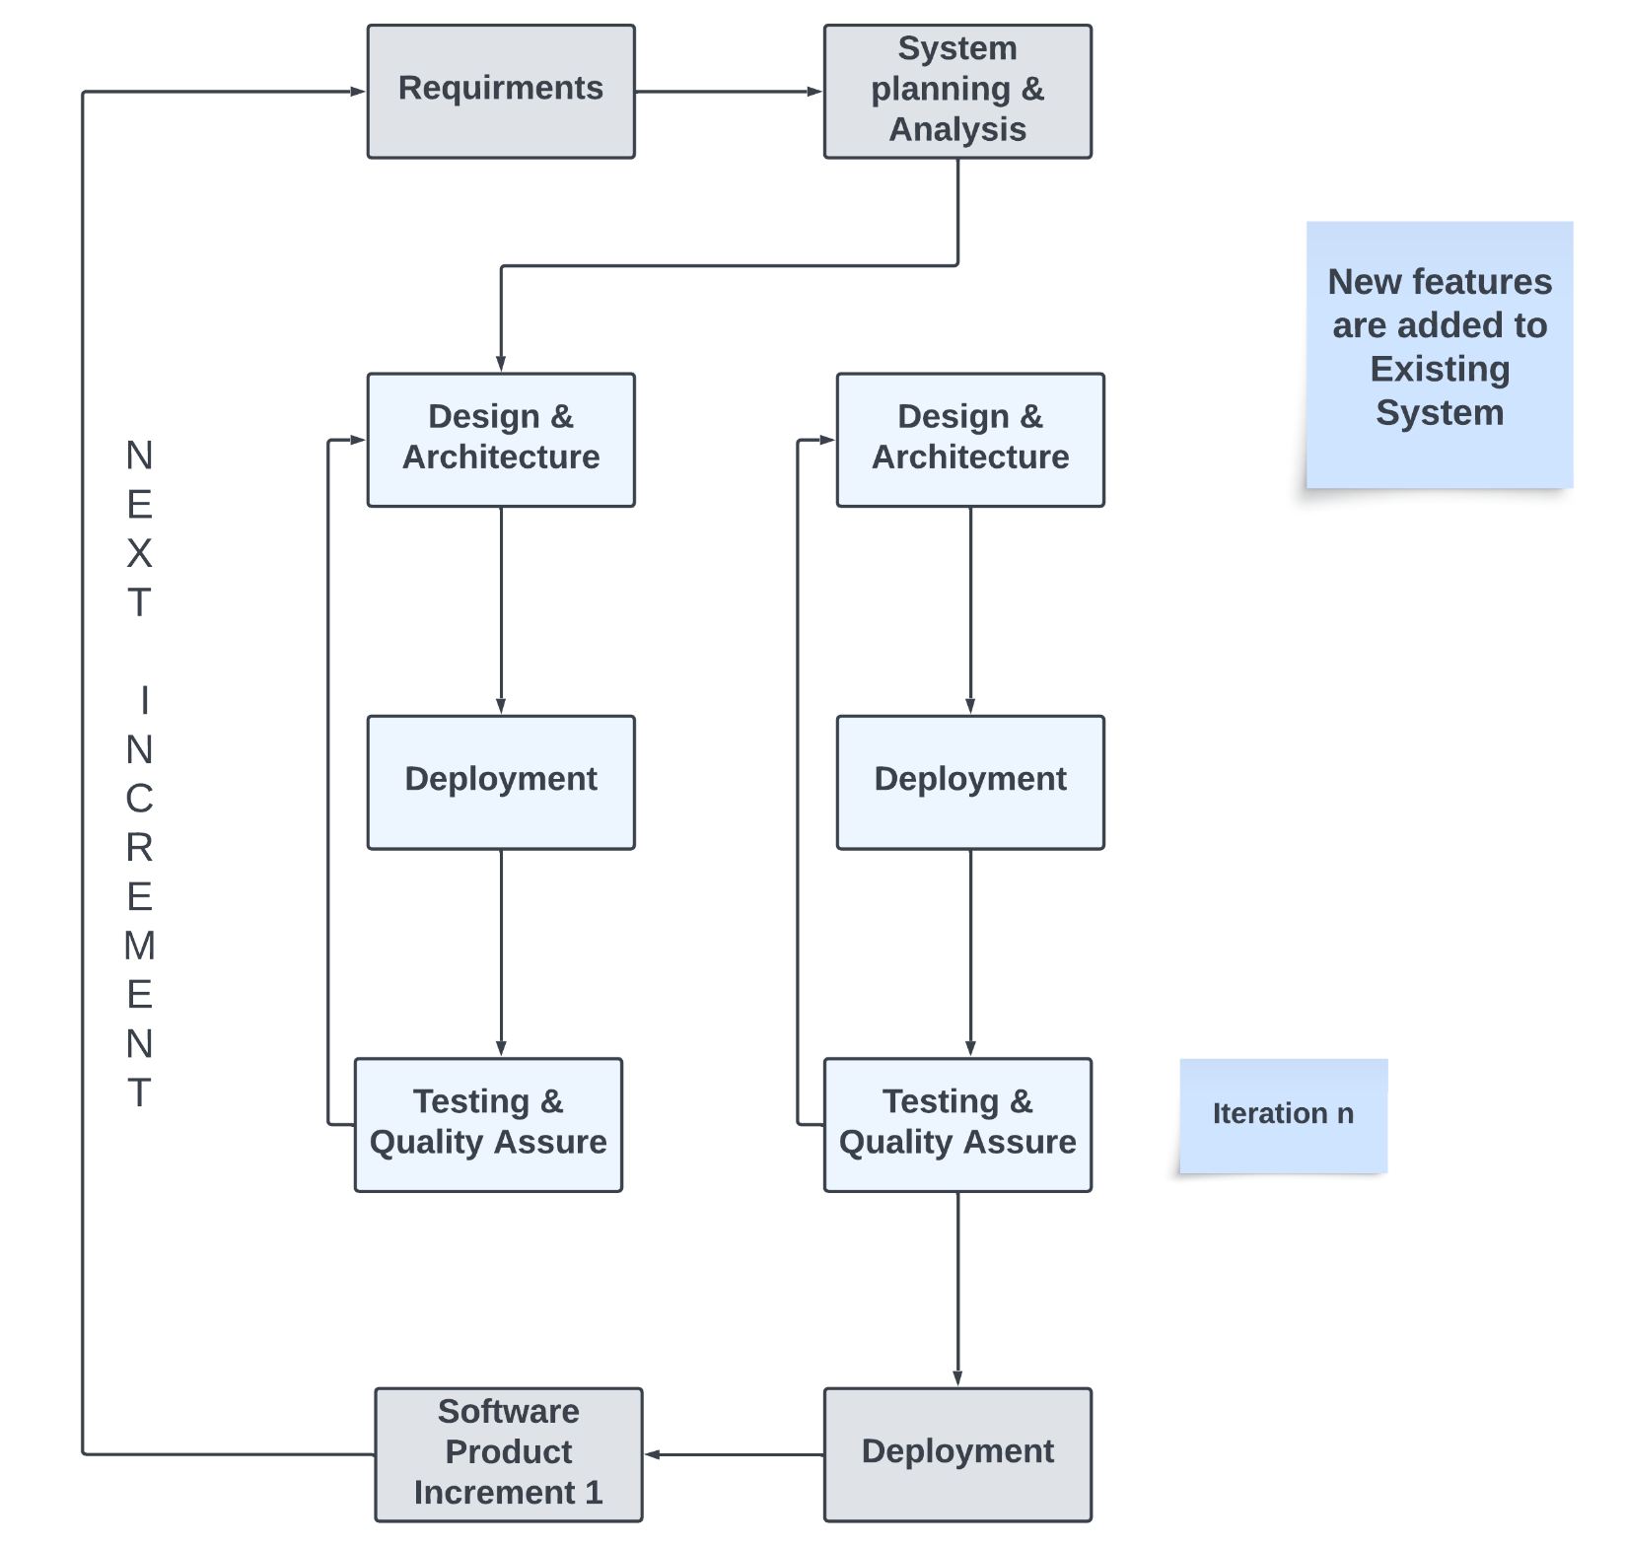

The iterative incremental model offers these benefits for content aggregator platforms:

**Flexibility:** Adapts to changing requirements and user needs.

**Faster Delivery:** Releases features incrementally for quicker time-to-market.

**User Feedback:** Gathers feedback early, improving alignment with user expectations.

**Risk Reduction:** Identifies and mitigates risks during smaller development phases.

**Quality:** Ongoing testing and refinement result in a higher-quality product.

**Efficient Resource Allocation**: Focuses on critical features in each iteration.

**Stakeholder Involvement:** Promotes regular interaction with stakeholders.

**Time to Market:** Brings the platform to market faster, generating revenue sooner.

**Experimentation**: Supports the testing of new data sources, formats, and algorithms.

This model combines structure and adaptability, ideal for content aggregator platforms in a dynamic digital landscape.

# Chapter 4

# 4 SYSTEM ANALYSIS AND PLANNING

System analysis and planning are pivotal stages in the development lifecycle of Vortex, our content aggregator platform. This comprehensive process involves a meticulous examination of system requirements, functionalities, and user interactions. The analysis phase delves into the intricacies of content aggregation, moderation, and user engagement strategies, ensuring a robust foundation for the platform. Concurrently, meticulous planning outlines the roadmap for implementation, addressing technical feasibility, economic viability, and operational efficiency. This dual-phase approach lays the groundwork for a seamless and user-centric platform, where every element is meticulously designed and strategically aligned with the overarching goals of Vortex. Through systematic analysis and thoughtful planning, Vortex aims to not only meet but exceed the expectations of its users in the dynamic landscape of content aggregation.

## 4.1 UML(UNIFIED MODELING LANGUAGE)

In crafting the architecture for Vortex, a content aggregator platform, Unified Modeling Language (UML) diagrams play a pivotal role in providing a visual blueprint of the system. The Use Case Diagram captures the various ways users interact with the platform, outlining essential functionalities such as content search, user registration, and premium subscriptions. The Activity Diagram illustrates the dynamic aspects of Vortex, showcasing the flow of activities and processes involved in content aggregation, user interactions, and system operations. Meanwhile, the Sequence Diagram delineates the chronological order of interactions between different components, offering a detailed perspective on how various elements collaborate to fulfill user requests. The Class Diagram encapsulates the static structure of Vortex, mapping out the essential entities, their attributes, and relationships, ensuring a well-organized and scalable system. Together, these UML diagrams provide a comprehensive visualization, guiding the development team in implementing a robust, user-centric, and functionally rich content aggregator in the form of Vortex.

### 4.1.1 Use-Case Diagram

The use case diagram for registration and content aggregation from APIs serves as a high-level blueprint of how Vortex functions. At its core, registration represents the initial gateway for users to access the platform, enabling them to create accounts and unlock the full potential of Vortex. On the other hand, content aggregation from APIs showcases the platform's dynamic capabilities, illustrating how Vortex seamlessly gathers and organizes content from diverse sources to offer users a centralized hub for their visual needs. This diagram not only provides a visual roadmap for user interactions but also encapsulates the essence of Vortex, where user-centricity and dynamic content come together to create a compelling and efficient system. It outlines how Vortex empowers users to navigate the digital vortex of creativity, inspiration, and convenience.

In a use case diagram, various symbols are used to represent different elements and relationships. Here are the key symbols and their meanings:

**Actor:**

Symbol: Stick figure or a block.

Meaning: Represents an external entity interacting with the system. Actors can be users, external systems, or other entities.

**Use Case:**

Symbol: Oval or ellipse.

Meaning:

Represents a specific functionality or task that the system performs.

**Association:**

Symbol: Line connecting an actor to a use case.

Meaning: Represents a relationship between an actor and a use case. It indicates that the actor is involved in the described functionality.

**System Boundary:**

Symbol: Rectangle or a box around use cases.

Meaning: Represents the boundary of the system. Use cases inside the boundary are part of the system, while actors outside the boundary interact with the system.

These symbols provide a visual representation of the interactions between actors and use- cases, as well as the relationships and dependencies among different elements in a use case diagram.

Use-case diagram for Admin Role:

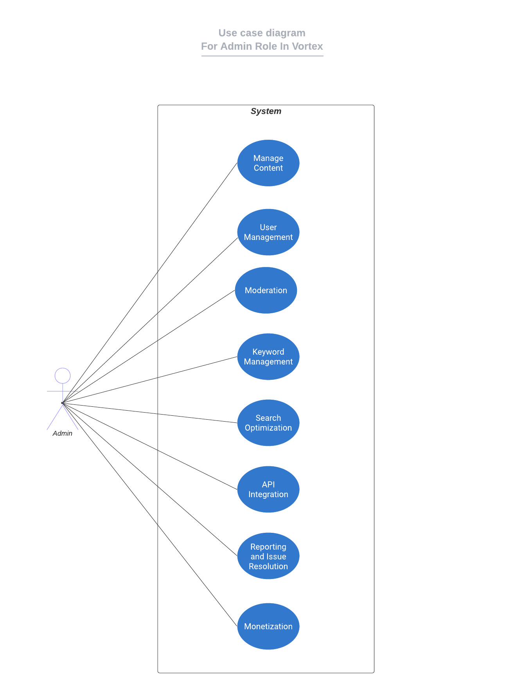

Use-Case diagram for User Features & Capabilities:

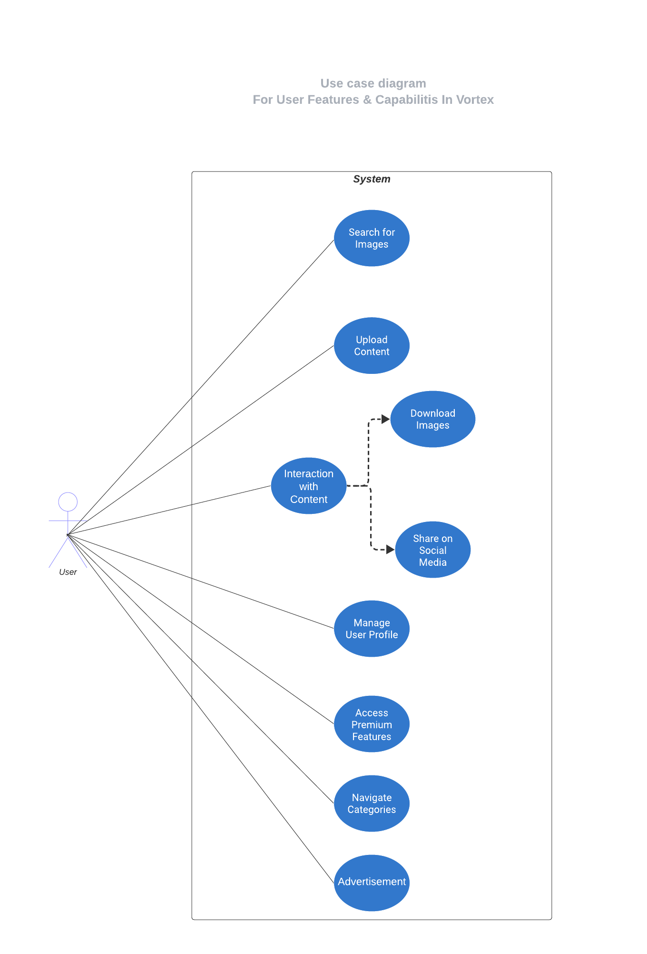

### 4.1.2 Activity Diagram

The activity diagrams for registration, user search & retrieval, and Go-Pro/Subscription processes within Vortex are pivotal in orchestrating the seamless flow of user interactions. The registration activity diagram showcases a streamlined onboarding experience, guiding users through account creation with precision. For user search & retrieval, the activity diagram ensures users effortlessly find and access the visual content they seek, enhancing their browsing experience. The Go-Pro/Subscription activity diagram underlines the simplicity of upgrading to premium features, allowing users to unlock additional benefits. These activity diagrams are the backbone of Vortex, where user engagement is harmonized with the platform's efficiency and convenience, culminating in a dynamic and user-centric experience.

In an activity diagram, various symbols are used to represent different elements and actions. Here are the key symbols used in activity diagrams and their meanings:

**Action or Activity:**

Symbol: Rounded rectangle.

Meaning: Represents a specific action or activity in the process.

**Initial Node:**

Symbol: Filled circle.

Meaning: Indicates the starting point of the activity diagram.

**Final Node:**

Symbol: Hollow circle.

Meaning: Represents the end or completion of the process.

**Decision Node:**

Symbol: Diamond shape.

Meaning: Represents a decision point where the flow can take different paths based on a

condition.

**Join Node:**

Symbol: Two or more incoming flows merging into one.

Meaning: Represents the merging of parallel paths.

**Control Flow Arrow:**

Symbol: Arrow.

Meaning: Represents the flow of control from one activity or decision point to another.

**Partition (Swimlane):**

Symbol: Vertical or horizontal rectangle with a label.

Meaning: Represents a partition or grouping of activities, often indicating different actors or subsystems.

These symbols help visualize the flow of activities, decisions, and interactions within a process, making it easier to understand and communicate complex workflows in a graphical format.

Activity diagram for registration:

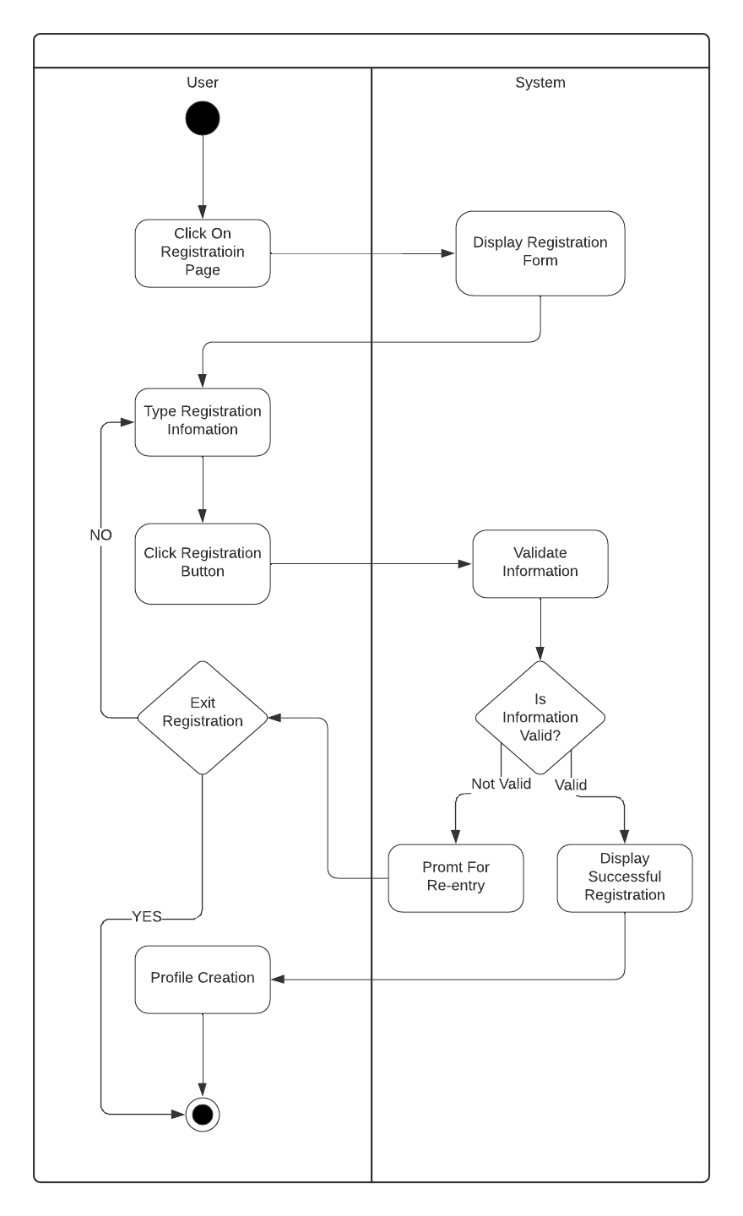

Activity diagram for User Search & Retrieval:

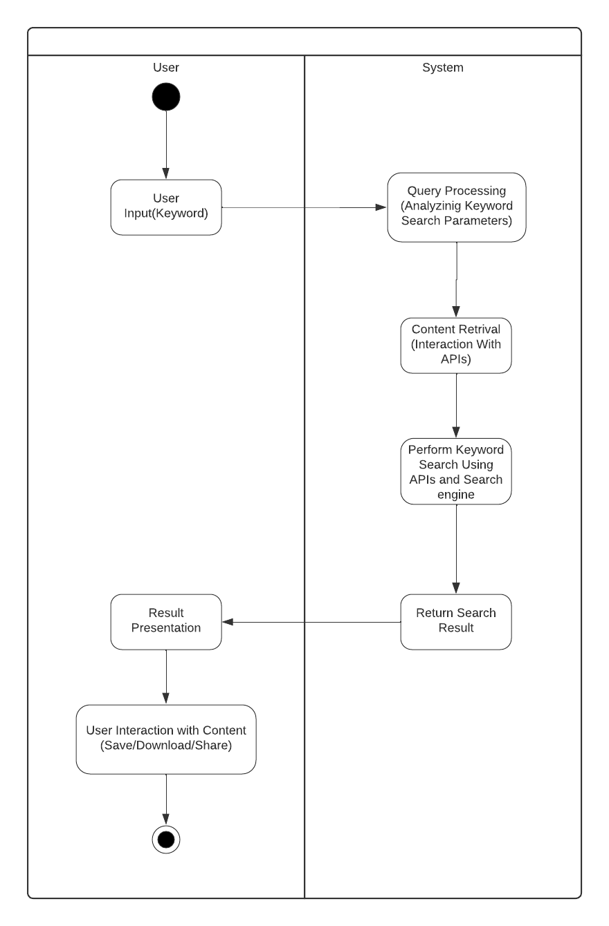

Activity diagram for Premium:

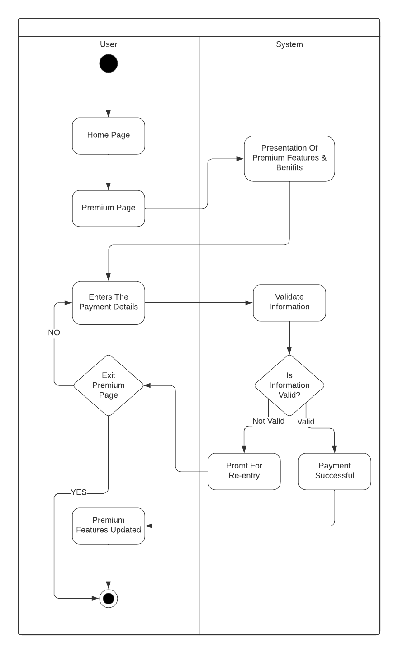

### 4.1.3 Sequence Diagram

In the dynamic journey of Vortex, sequence diagrams serve as our guiding threads, weaving the intricate processes of registration, API integration, and content upload into a cohesive narrative. Through the registration sequence, users embark on their Vortex experience, while API integration unfolds as the bridge connecting our platform with a vast world of content sources. The upload content feature empowers users to share their creative vortex with the world. In these sequences, each step is meticulously choreographed, ensuring that Vortex's engine hums harmoniously to fulfill user aspirations and platform potential. It is in these intricacies that Vortex's vibrant story unfolds, powered by seamless interactions and connections.

In a sequence diagram, various symbols and notations are used to represent different elements and interactions. Here are some common symbols and their meanings:

**Lifeline:**

Representation: Vertical dashed lines extending downwards.

Meaning: Represents the lifespan of an object or participant in the sequence.

**Actor:**

Representation: Stick figures or blocks outside the lifelines.

Meaning: Represents an external entity interacting with the system.

**Message:**

Representation: Arrowed lines between objects or participants.

Meaning: Represents a communication or interaction between objects. It includes details such as the message name, parameters, and return values.

**Self Message:**

Representation: Arrowed line looping back to the same lifeline.

Meaning: Represents a message sent from an object to itself.

These symbols and notations help to visually represent the flow of interactions between objects and participants in a system during a specific scenario or process.

Sequence diagram for Registration:

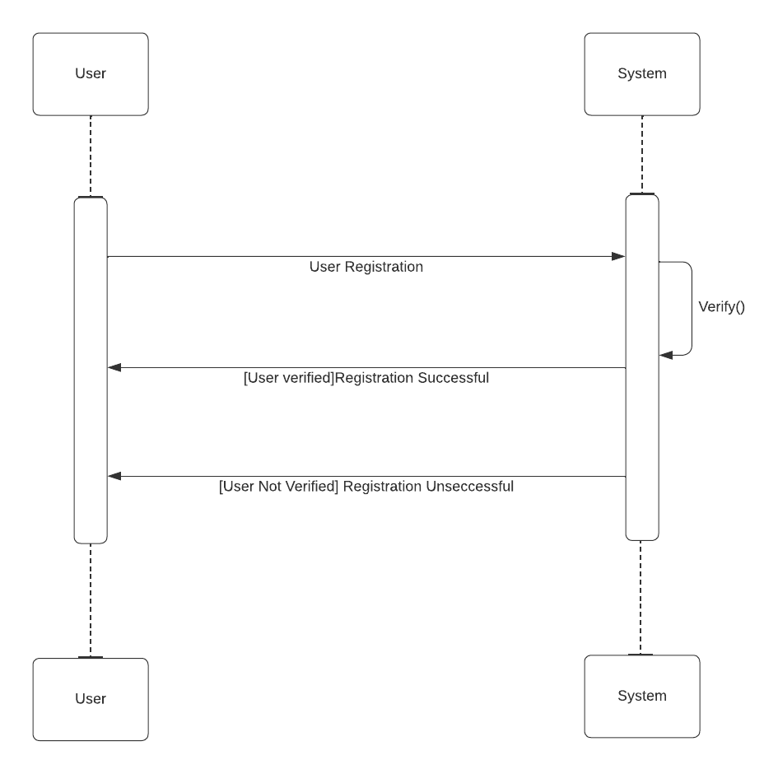

Sequence diagram for API Integration:

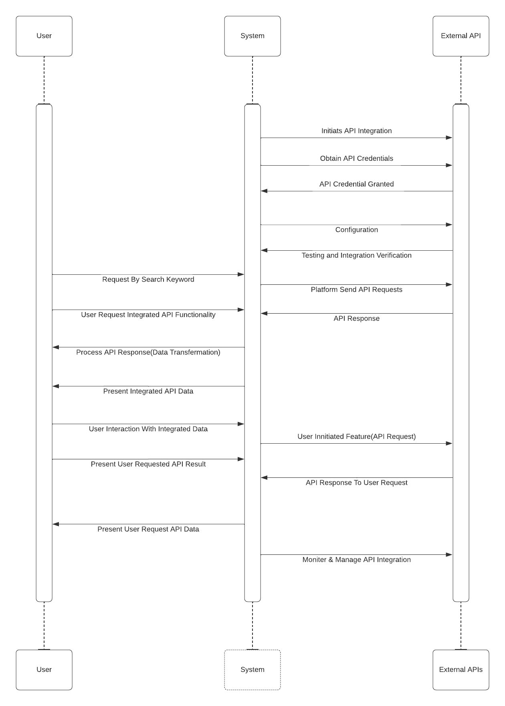

Sequence diagram for Upload Content by user:

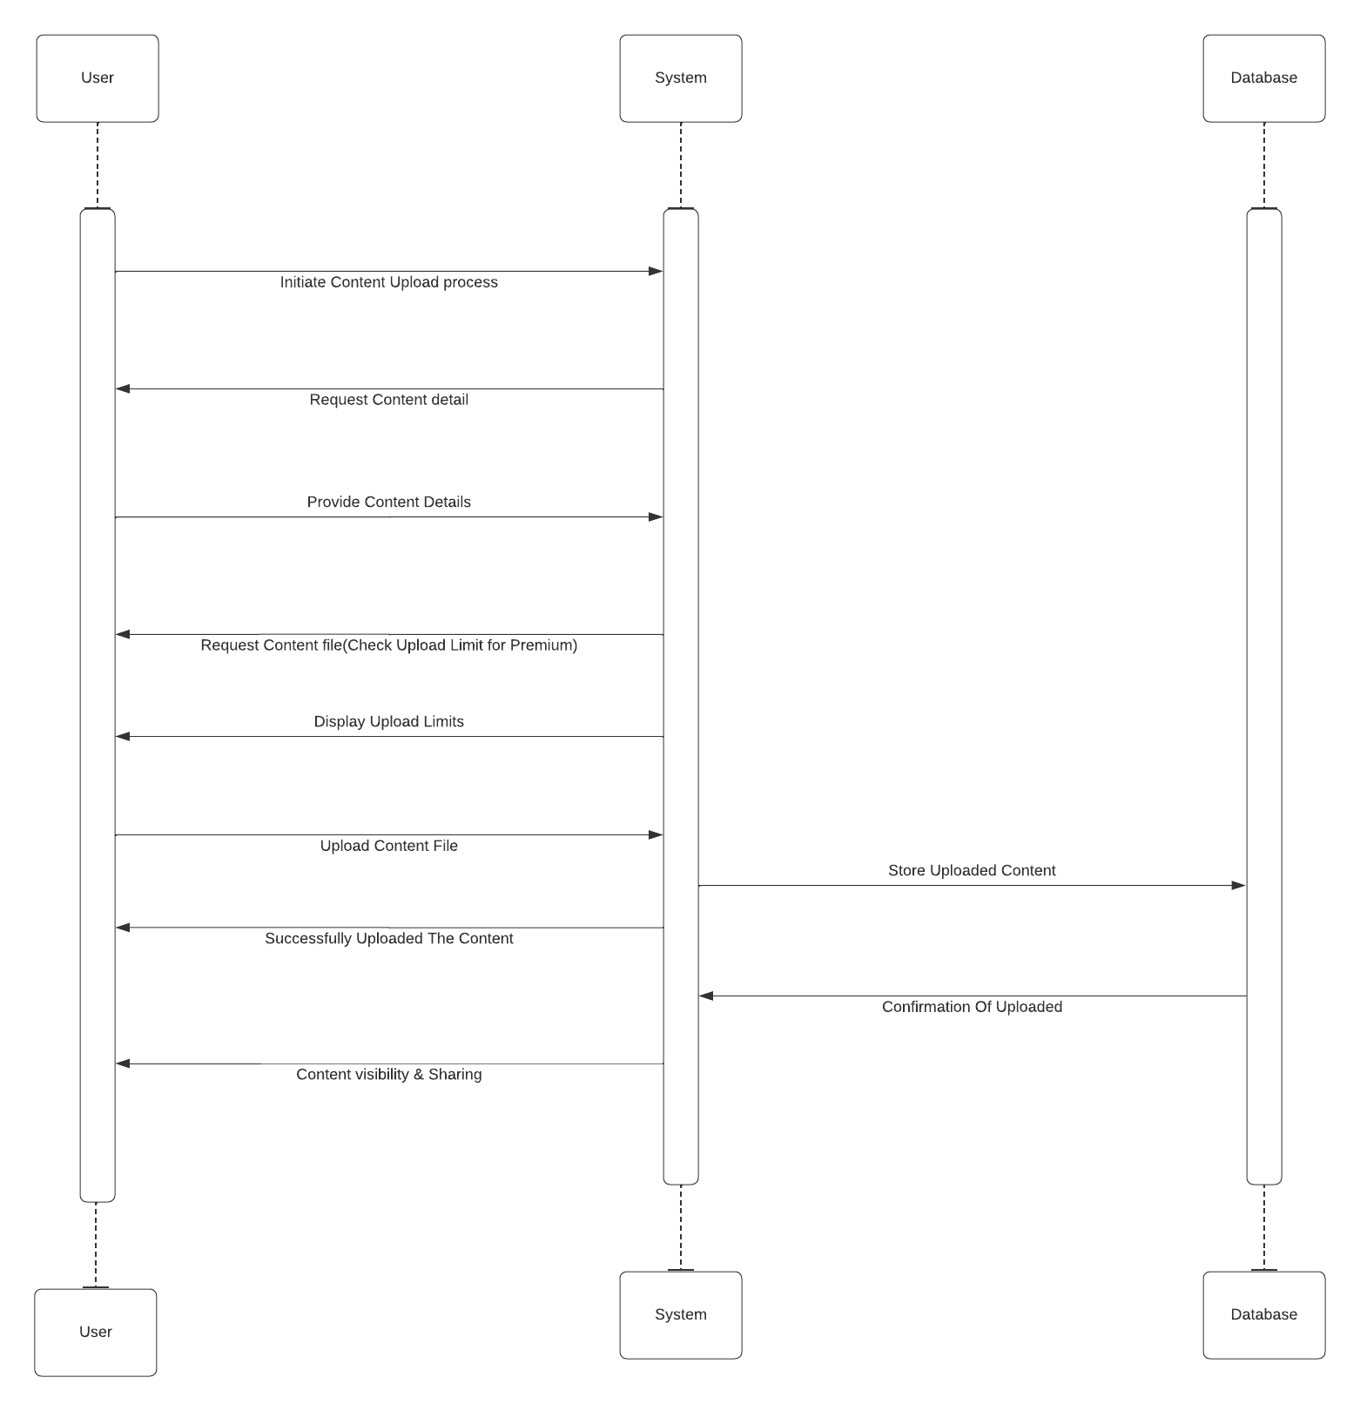

### 4.1.4 Class Diagram

The class diagram for Vortex provides a concise visual representation of the platform's structure and relationships. It outlines the essential classes, their attributes, and methods, offering a foundational blueprint for understanding how different components interact within the content aggregator. This diagram is instrumental in depicting the static aspects of Vortex's architecture, facilitating a clear comprehension of the platform's core entities and their associations.

In a class diagram in Unified Modeling Language (UML), various symbols are used to represent different elements. Here are some common symbols and their meanings:

**Class:**

Symbol: Rectangle divided into three compartments.

Meaning: Represents a class, with the top compartment containing the class name, the middle compartment for attributes, and the bottom compartment for methods.

**Association:**

Symbol: Line connecting two classes, optionally with an arrow indicating the direction.

Meaning: Represents a relationship between two classes. The arrow may indicate the direction of the relationship.

**Multiplicity:**

Symbol: Numeric range notation (e.g., 0..1, 1..*, etc.) near the association line.

Meaning: Specifies the number of instances of one class related to a single instance of another class.

**Aggregation:**

Symbol: Hollow diamond shape at the end of the association line.

Meaning: Represents a "whole-part" relationship between two classes, where one class is a part of another.

**Composition:**

Symbol: Filled diamond shape at the end of the association line.

Meaning: Similar to aggregation but indicates a stronger relationship, often implying that the part cannot exist without the whole.

**Inheritance/Generalization:**

Symbol: Hollow triangle connecting the child class to the parent class.

Meaning: Represents an "is-a" relationship, where the child class inherits attributes and

behaviors from the parent class.

**Interface:**

Symbol: Rectangle with the stereotype "<<interface>>" or the label "interface" above the class name.

Meaning: Represents an interface, which defines a contract for a set of methods that

implementing classes must provide.

**Dependency:**

Symbol: Dashed arrow connecting two classes.

Meaning: Indicates a relationship where a change in one class may affect another class.

Class Diagram for whole system:

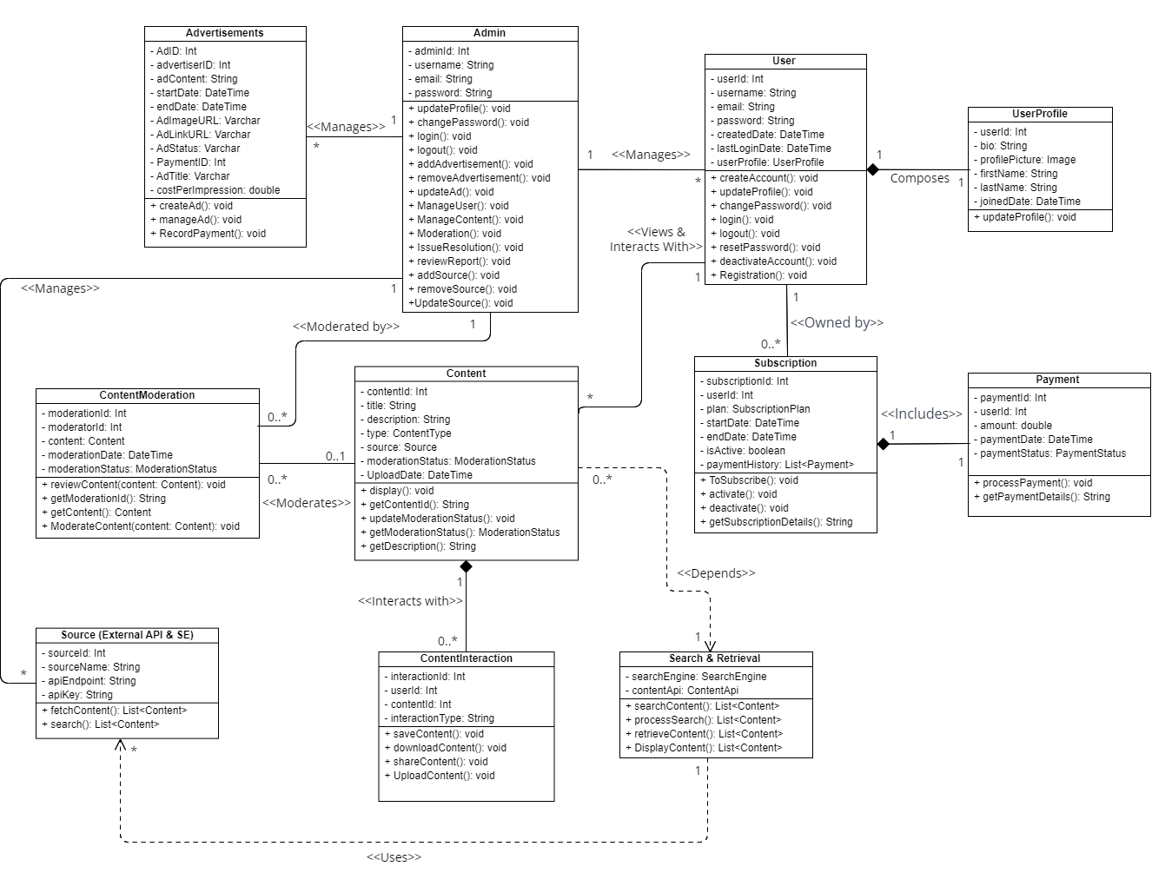

## 4.2 System Flow Diagram

A System Flow Diagram is a pivotal visual representation in the world of system analysis and design. It serves as a dynamic blueprint, depicting the intricate web of activities, data, and interactions within a software or information system. The diagram, characterized by a flow of interconnected processes and data, allows stakeholders to grasp the holistic view of a system's operation. By illustrating the sequence and dependencies of activities, it becomes an essential tool for planning, refining, and optimizing processes, ensuring the efficient and seamless operation of complex systems. In essence, a System Flow Diagram transforms abstract concepts into a tangible map, guiding the development and enhancement of software and information systems in the digital landscape.

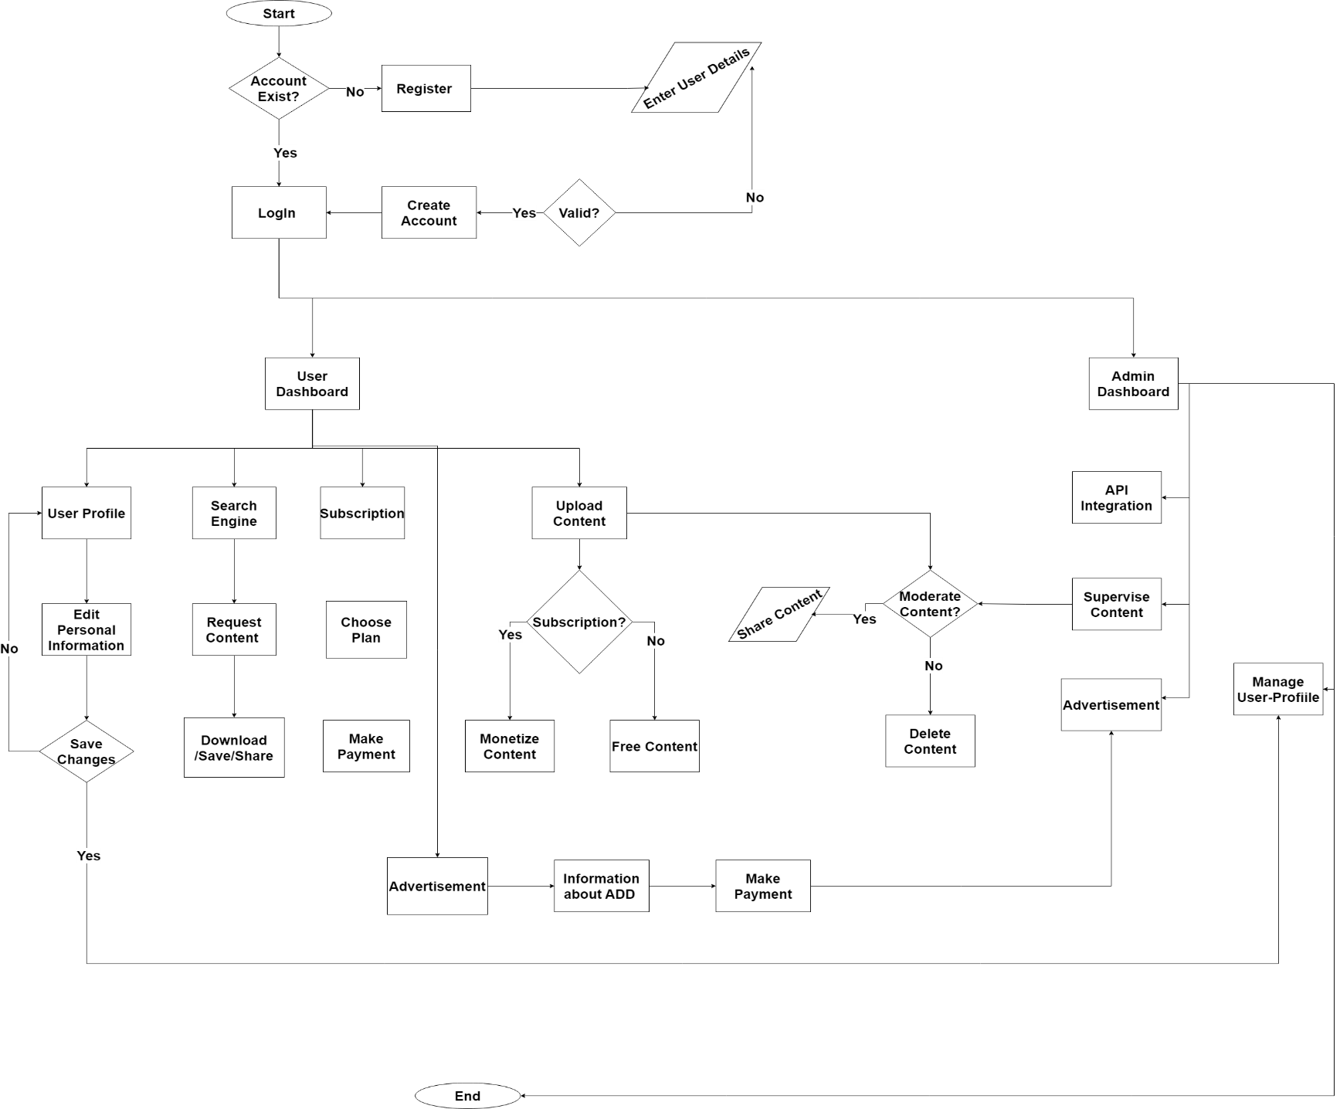

### 4.2.1 Architecture Context Diagram

An Architecture Context Diagram for Vortex, our content aggregator platform, serves as a concise yet insightful representation of the platform's structural framework. At its core, this diagram outlines the relationships between various components, including superordinate and subordinate systems, actors, and peer-level systems. Superordinate systems represent overarching entities influencing or being influenced by Vortex, while subordinates delve into the specific subsystems that constitute the platform. Actors encompass the diverse user roles interacting with Vortex, and peer-level systems highlight the interconnected elements within the broader ecosystem. This diagram provides a high-level view, offering a valuable perspective on the relationships and interactions that define Vortex within its architectural context.

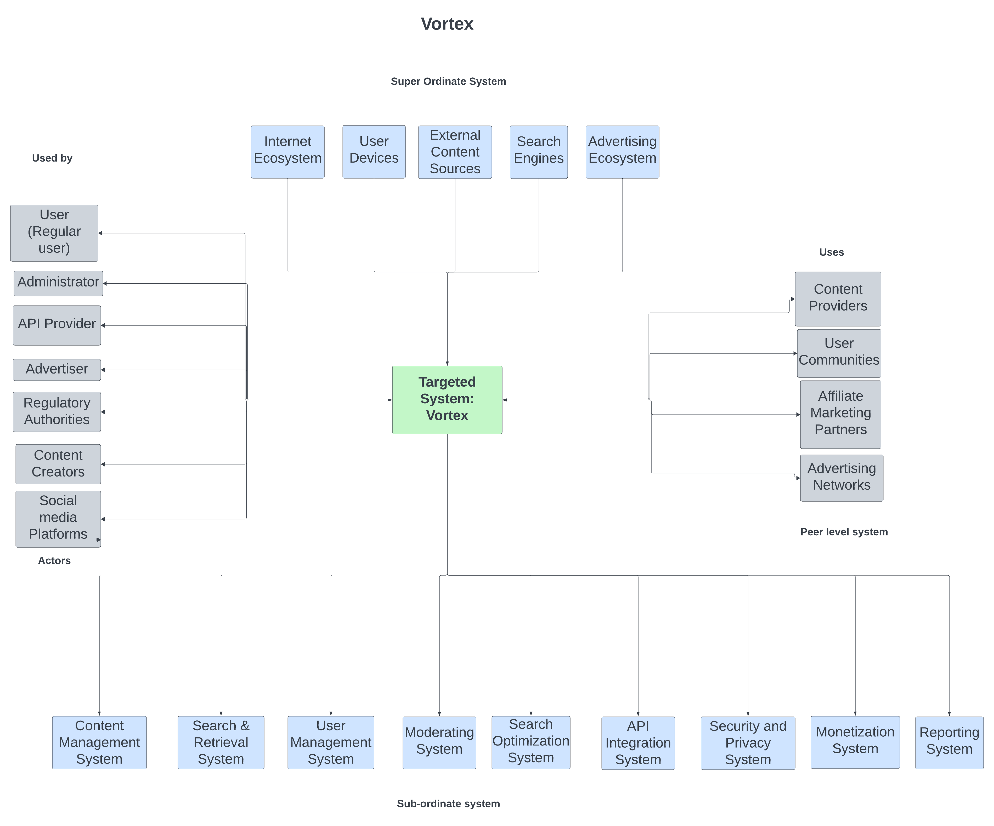

## 4.3 DATA DICTIONARY

In the context of our Vortex content aggregator platform, a data dictionary serves as a comprehensive repository that centralizes data definitions, constraints, and attributes. This structured catalog not only enhances data management but also ensures consistency and accuracy in our system. By meticulously documenting the data used within Vortex, we create a reference point that simplifies data maintenance and understanding. The data dictionary is more than a mere list; it is a dynamic tool that aids in the smooth exchange of information, streamlining system processes, and contributing to the overall efficiency and integrity of our platform. It's an essential component of our data-driven journey, ensuring that Vortex operates seamlessly while delivering a rich and immersive user experience.

Table for Admin:

|  |  |  |  |  |
| --- | --- | --- | --- | --- |
| Field Name | Data Type | Field Size | Constraint | Description |
| adminId | Integer |  | Primary Key | Unique identifier for the admin. |
| username | String | 50 |  | Unique username for the admin. |
| email | String | 255 | Unique | Email address of the admin. |
| password | String |  |  | Password for admin authentication. |

Table for User Profile:

|  |  |  |  |  |
| --- | --- | --- | --- | --- |
| Field Name | Data Type | Field Size | Constraint | Description |
| UserId | Integer |  | Primary Key, Not Null | Unique identifier for each user |
| Bio | Text | 255 |  | Brief description or biography of the user |
| ProfilePicture | Image |  |  | User's profile picture |
| FirstName | String | 50 | Not Null | First name of the user |
| LastName | String | 50 | Not Null | Last name of the user |
| JoinDate | Date |  | Not Null | Date when the user joined the platform |

Table for Users:

|  |  |  |  |  |
| --- | --- | --- | --- | --- |
| Field Name | Data Type | Field Size | Constraint | Description |
| UserID | Integer | 10 | Primary Key | Unique identifier for a user |
| Username | Varchar | 50 | Unique, Not Null | User's username |
| Email | Varchar | 100 | Unique, Not Null | User's email address |
| Password | Varchar | 100 | Not Null | Encrypted password |
| RegistrationDate | Datetime |  | Not Null | Date and time of user registration |
| LastLoginDate | Datetime |  |  | Date and time of user's last login |
| UserProfile |  |  |  | UserProfile |

Table for Content:

|  |  |  |  |  |
| --- | --- | --- | --- | --- |
| Field Name | Data Type | Field Size | Constraint | Description |
| ContentID | Integer | 10 | Primary Key | Unique identifier for a content item |
| UserID | Integer | 10 | Foreign Key | ID of the user who uploaded the content |
| Title | Varchar | 255 | Not Null | Title or name of the content item |
| SourceName | Varchar | 100 | Not Null | Name or label for the content source |
| Description | Text |  |  | Description or details of the content |
| UploadDate | Datetime |  | Not Null | Date and time of content upload |
| type | String | 50 | Not Null | Type of Content which will be uploaded by the user |
| ModerationStatus |  |  |  | ModerationStatus |

Table for Content Moderation:

|  |  |  |  |  |
| --- | --- | --- | --- | --- |
| Field Name | Data Type | Field Size | Constraint | Description |
| ModerationID | Integer | N/A | Primary Key | Unique identifier for a moderation action |
| ModeratorId | Ineger | N/A | Forieng Key(referances User) | Identifier for the moderator overseeing the process. |
| ContentID | Integer | 10 | Foreign Key | ID of the content item undergoing moderation |
| ModerationStatus | Varchar | N/A | Not Null | Status of the content moderation (e.g., approved, rejected) |
| ModerationDate | Datetime | N/A | Not Null | Date and time of the moderation action |

Table for Payments:

|  |  |  |  |  |
| --- | --- | --- | --- | --- |
| Field Name | Data Type | Field Size | Constraint | Description |
| PaymentID | Integer | 10 | Primary Key | Unique identifier for a payment |
| UserID | Integer | 10 | Foreign Key | ID of the user making the payment |
| PaymentAmount | Decimal | 10,2 | Not Null | The amount of the payment |
| PaymentDate | Datetime |  | Not Null | Date and time of the payment |
|  |  |  |  |  |
| PaymentStatus | Varchar | 20 | Not Null | Status of the payment (e.g., successful, pending, failed) |

Table for Advertisements:

|  |  |  |  |  |
| --- | --- | --- | --- | --- |
| Field Name | Data Type | Field Size | Constraint | Description |
| AdID | Integer | 10 | Primary Key | Unique identifier for an advertisement |
| UserID | Integer | 10 | Foreign Key | Unique identifier for a user |
| AdvertiserID | Integer | 10 | Foreign Key | ID of the advertiser or entity placing the ad |
| AdTitle | Varchar | 255 | Not Null | Title or name of the advertisement |
| AdDescription | Text |  |  | Description of the advertisement and its content |
| AdImageURL | Varchar | 255 | Not Null | URL of the ad image or content |
| AdLinkURL | Varchar | 255 | Not Null | URL that the ad links to when clicked |
| StartDate | Date |  | Not Null | Start date of the advertisement campaign |
| EndDate | Date |  | Not Null | End date of the advertisement campaign |
| AdStatus | Varchar | 20 | Not Null | Status of the advertisement (e.g., active, inactive) |
| PaymentID | Integer | 10 | Foreign Key | Unique identifier for a payment |

Table for Subscriptions (Premium Features).

|  |  |  |  |  |
| --- | --- | --- | --- | --- |
| Field Name | Data Type | Field Size | Constraint | Description |
| SubscriptionID | Integer | 10 | Primary Key | Unique identifier for a subscription |
| UserID | Integer | 10 | Foreign Key | ID of the user who subscribed to a premium feature |
| SubscriptionType | Varchar | 50 | Not Null | Type of subscription (e.g., Premium, VIP) |
| SubscriptionStatus | Varchar | 20 | Not Null | Status of the subscription (e.g., active, inactive) |
| SubscriptionStartDate | Date |  | Not Null | Start date of the subscription |
| SubscriptionEndDate | Date |  | Not Null | End date of the subscription |
| PaymentAmount | Decimal | 10,2 | Not Null | The amount paid for the premium feature |
| PaymentDate | Datetime |  | Not Null | Date and time of the subscription payment |
| PaymentId | Varchar | 100 | Foreign Key | Unique identifier for the subscription transaction |

Table for Source(External API & SE):

|  |  |  |  |  |
| --- | --- | --- | --- | --- |
| Field Name | Data Type | Field Size | Constraint | Description |
| SourceID | Integer | - | Primary key | Unique identifier for each source. |
| SourceName | String | 255 | Not Null, unique | Name of the external source. |
| APIEndpoint | String | 255 | Not Null | Endpoint for External API. |
| APIKey | String | 255 | Not Null | API key for authentication. |

Table for Content Interaction:

.

|  |  |  |  |  |
| --- | --- | --- | --- | --- |
| Field Name | Data type | Field Size | Constraint | Description |
| InteractionId | Integer |  | Primary Key, Auto-increment | Unique identifier for each interaction. |
| UserId | Integer |  | Foreign Key (references Users.UserId) | Identifier of the user involved in the interaction. |
| InteractionType | String | 50 |  | Type of interaction (e.g., like, share, comment). |
| ContentId | Integer |  | Foreign Key (references Content.ContentId) | Identifier of the content being interacted with. |

Table for Search & Retrieval.

|  |  |  |  |  |
| --- | --- | --- | --- | --- |
| Field Name | Data Type | Field Size | Constraints | Description |
| searchengine |  |  |  | Search Engine of Browser. |
| contentAPI |  |  |  | Public API which exists on the internet or API from the different platforms. |

## 4.4 USER INTERFACE

Vortex boasts an intuitive and visually captivating User Interface (UI) that caters to the diverse needs of its users. The homepage serves as a dynamic entry point, presenting trending content and featured collections, inviting users to explore a world of visual inspiration. The login and registration pages ensure a secure and personalized experience, fostering a sense of community among users. The user profile becomes a personalized hub where individuals can curate their Vortex journey, managing preferences and tracking contributions. The sleek Hamburger Menu simplifies navigation, granting users quick access to various sections of the platform.

The Inspiration Page curates a rich collection of diverse images, sparking creativity and offering a visual feast. Vortex goes beyond content curation with an Advertisement Page, providing a dedicated space for users and businesses to promote their content. The Contributor Page encourages user-generated content, fostering collaboration and community engagement. The Premium Subscription Page offers exclusive features, allowing subscribers to unlock additional functionalities and access exclusive content.

For those curious about Vortex's story, the About Us page provides a comprehensive overview, detailing the platform's mission, vision, and the dedicated team driving its success. The Contact Us page ensures open lines of communication, welcoming user inquiries and feedback. Finally, the History Page offers a nostalgic journey, chronicling Vortex's evolution and impactful milestones. Through thoughtful design and user-centric features, Vortex's UI creates an immersive and enjoyable digital environment for all.

Vortex's UI is designed to be not just a gateway to visual content but a user-centric platform that caters to diverse needs, fosters creativity, and provides an enjoyable digital experience.

**UI Design for Vortex:**

Home Page:

The gateway to Vortex, where users are greeted with a visually appealing and intuitive layout, showcasing trending content, featured collections, and quick access to various sections.

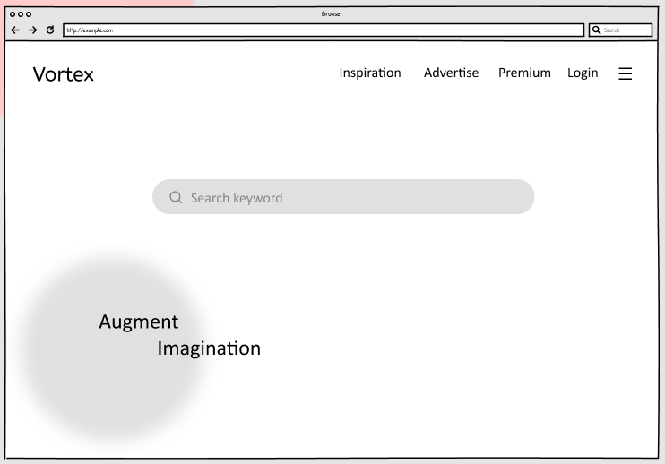

Registration Page:

An inviting space for new users to join the Vortex community. The registration process is user-friendly, requiring essential information for a personalized experience.

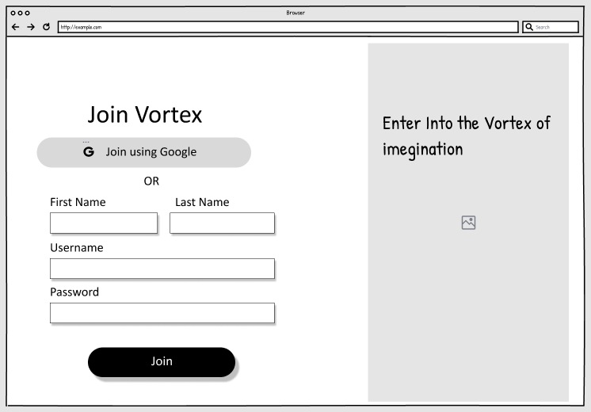

Login Page:

A secure entry point for registered users, ensuring privacy and personalized interactions. Users can access their accounts, providing a secure environment for content exploration.

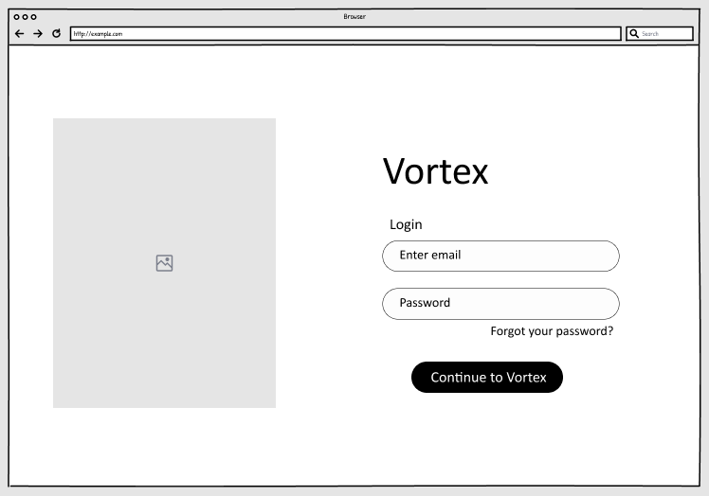

User Profile:

A customizable hub where users manage their preferences, view saved images, and track their contributions. This page allows users to curate their Vortex journey.

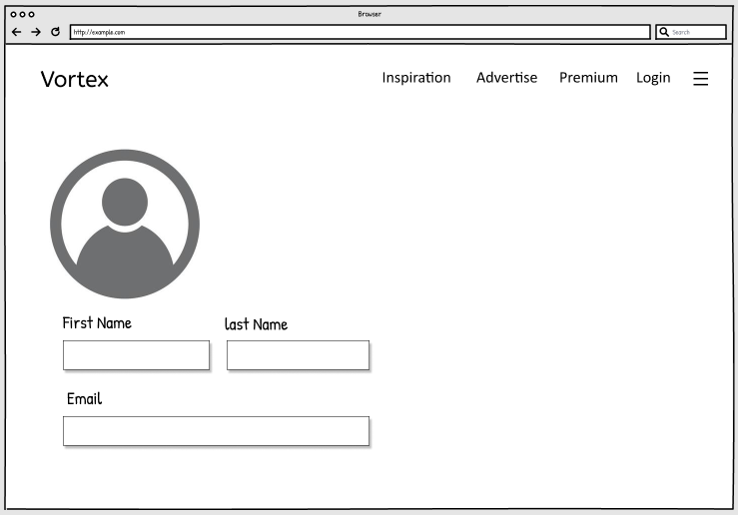

Hamburger Menu:

A sleek navigation tool offering easy access to different sections of Vortex. Users can effortlessly explore various features and functionalities from this menu.

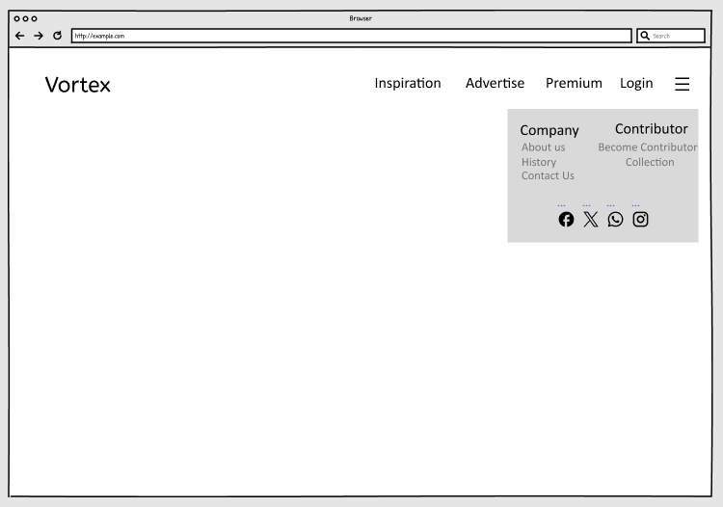

Inspiration Page:

A curated collection of diverse and inspiring images, categorized for user exploration. This section fuels creativity and serves as a visual inspiration hub.

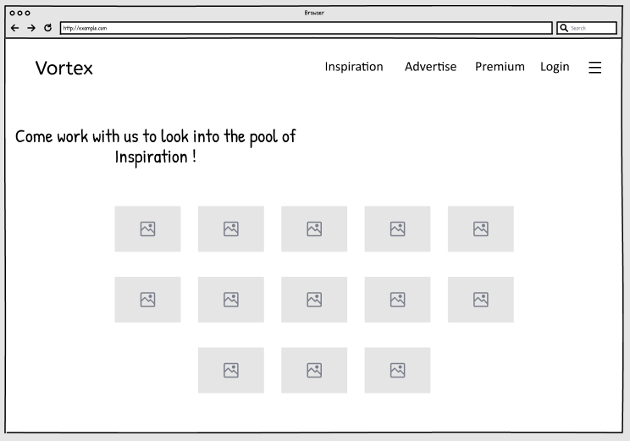

Advertisement Page:

A dedicated space for users and businesses to showcase advertisements. This feature provides an avenue for those looking to promote their content on the platform.

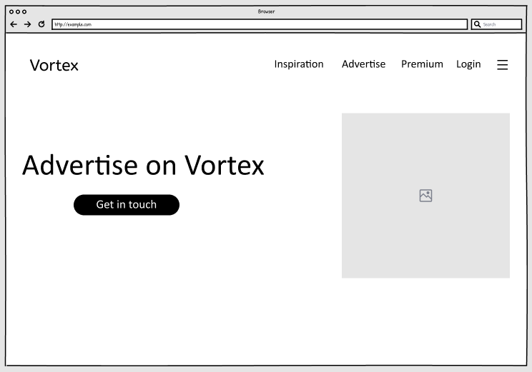

Premium Subscription Page:

An exclusive section offering premium features for subscribers. Users can explore subscription plans, unlocking additional functionalities and exclusive content.

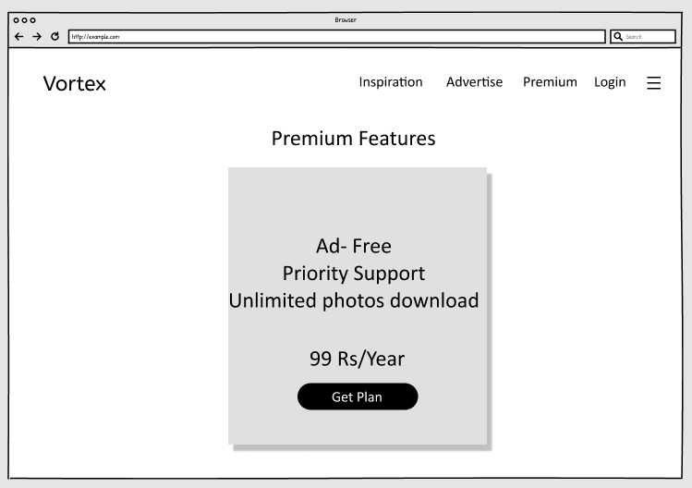

Contributor Page:

A user-friendly interface for contributors to upload and share their images with the Vortex community. This page encourages user-generated content and fosters a collaborative environment.

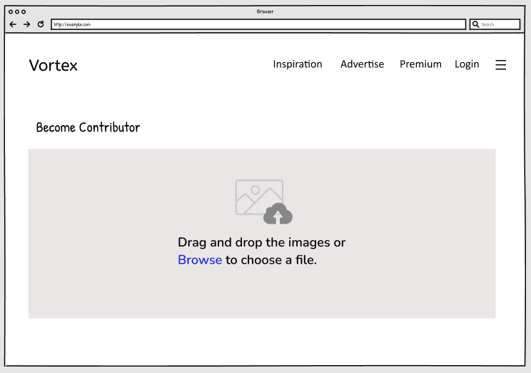

About Us:

A comprehensive overview of Vortex, detailing its mission, vision, and the team behind the platform. Users gain insights into the core values that drive the content aggregator.

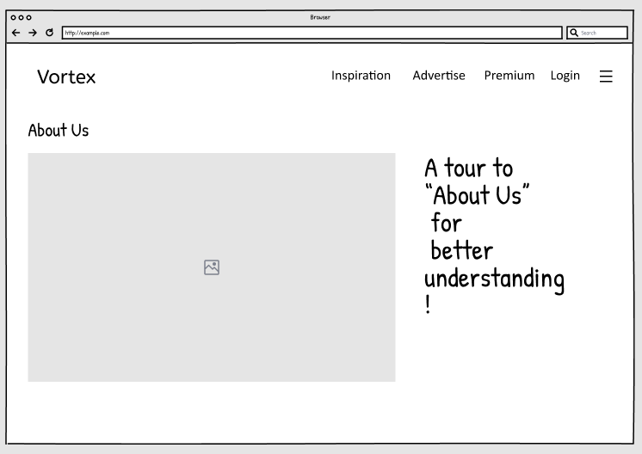

History Page:

A nostalgic journey showcasing the evolution of Vortex. Users can explore the platform's developmental milestones and its impactful journey.

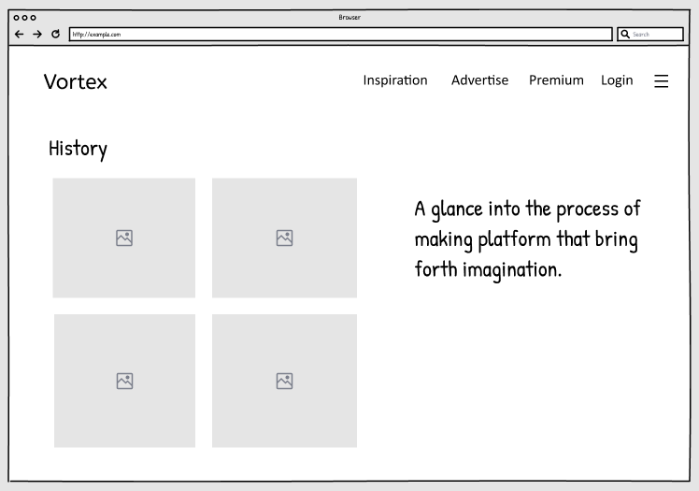

Contact Us:

An interactive space for user inquiries, feedback, and support. This page ensures effective communication between users and the Vortex team.

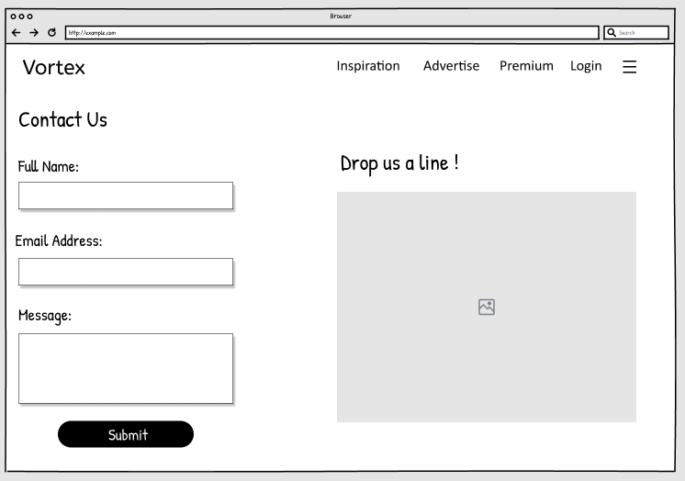

## 4.5 SYSTEM NAVIGATION

The System Navigation Diagram for Vortex is a dynamic visual guide that maps the digital journey users will undertake within our content aggregator platform. It provides a clear, intuitive roadmap, ensuring that users can seamlessly explore and interact with the platform's various features and functionalities. This diagram acts as a compass, ensuring that users can navigate Vortex with ease, enhancing their overall experience and engagement. It's a fundamental tool in shaping the platform's user-centric design, making Vortex a user-friendly and accessible destination for discovering and sharing high-quality visual content.

